RETIRED COLONEL PEDRO BAÑOS, TIES TO RUSSIA AND INFLUENCE IN THE INTERESTS
OF THE RUSSIAN GOVERNMENT
In Spain, particular attention should be paid to the former head180 of the Counterintelligence and Security Directorate of the European Corps (a tactical association of the armed forces of the EU member states – Eurocorp), former head181 of the Ge- opolitical Analysis Department of the General Secretariat of Defense Policy of the Spanish Ministry of De- fense, and a former professor182 at the Higher School of the Spanish Armed Forces, retired Colonel Pe- dro Baños. Pedro Baños cherishes a personal story of his connections with Russia itself, as well as indi- viduals and organisations linked to Russia. Both before and after the full-scale invasion of Ukraine, he has exerted influence in line with the in- terests of the Russian government.

Pedro Baños contributes to Span- ish-language Russian state-run platforms such as Russia Today and Sputnik, where he has consistently advocated for the interests of the Russian Federation. For instance, in 2015, following Russia’s aggression against Ukraine, Baños participat- ed in a radio program183 on Sputnik,
where he advocated forming an al- liance between the EU and Russia. In an interview with Russia Today184, Colonel Baños suggested the in- volvement of a Ukrainian fighter jet in the downing of Malaysian Boe- ing MH17 over Donbas, a narrative aligned with the official stance185 of the Russian government.

In 2018, Pedro Baños was consid- ered186 for the position of head of the Department of National Secu- rity (Departamento de Seguridad Nacional) in the government of Pe- dro Sánchez. However, Baños did not receive this position because of the public outcry over his ties to Russia. Russia Today187 and Sput- nik188 reported then on an alleged “planned attack” by Western intel- ligence against the Spanish officer.

Both before and after Russia’s inva- sion of Ukraine, Baños has worked to undermine the European Union’s sanctions against Russia. In this con- text, he referred189 to the EU sanc- tions in response to the occupation of Crimea as “an unnecessary mis- take”. Furthermore, in 2023, during an interview with the Spanish chan- nel Canal 26, he emphasised190 that “Western sanctions against Russia have backfired”.

This study reveals the cooperation of Pedro Baños with individuals and or- ganisations linked to the ideologist

Pedro Baños was considered for the position

of head of the Department of National Security, but he did not get the appointment because of the public outcry over his ties to the Russian Federation. Russia Today and Sputnik then reported on an alleged “planned attack” against the officer

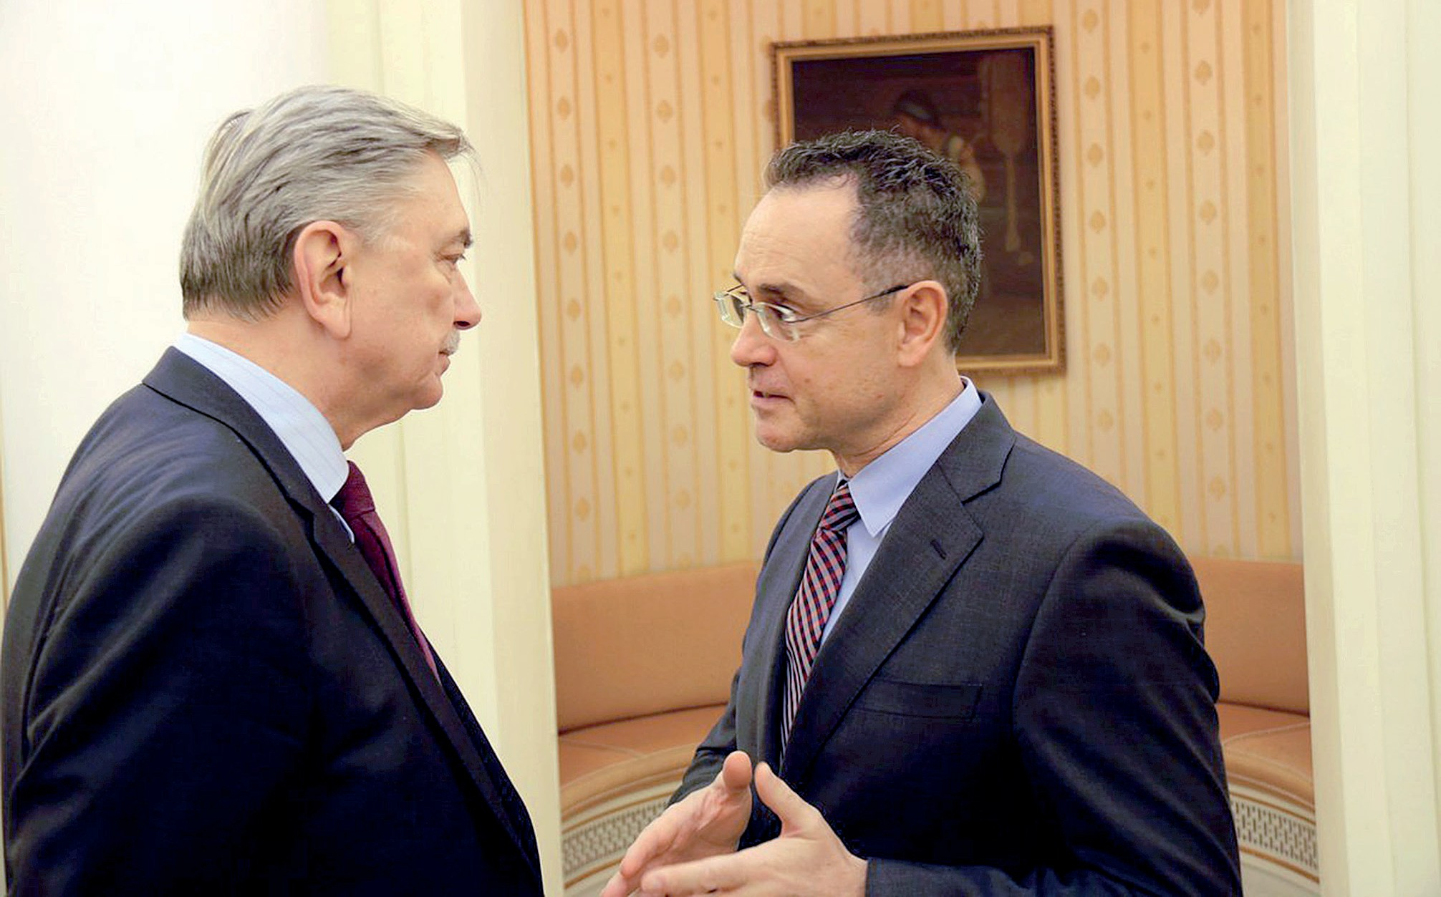

Former Chief of Eurocorp
Counterintelligence Pedro Baños
(on the right) and Russian Ambassador to Spain Yuri Korchagin, 2020

of “Russian World”, Alexander Dugin, repeatedly mentioned in this report. Thus, in 2019, Baños participated in a conference on metapolitics or- ganised by the cultural association OHKA and the neo-fascist191 publish- ing house Fides. OHKA is a regular contributor192 to the Geopolitica.ru platform, which, according to the findings193 of the National Agency for the Prevention of Corruption, is con- trolled by Alexander Dugin. During this conference, Baños presented his book “Soros: Destroying Spain”. Another participant194 of the confer- ence was the aforementioned ob- server of “local elections” in the so- called “DPR” and the editor-in-chief of the Spanish Institute of Geopoli- tics (IGE), Enrique Refoyo.

In turn, in 2019, the Geopolitica.ru platform republished Pedro Baños’ program “Vision Geopolitic”, featur- ing Juan Aguilar, the currently act- ing director of the Spanish Institute of Geopolitics, as a guest.
Since Russia’s full-scale invasion of Ukraine, Reserve Colonel Pedro Baños has consistently exerted in- fluence aimed at undermining the supply of military and technical as- sistance to Ukraine while justifying Russian aggression. Thus, at a literary conference in Pamplona, Spain, Pe- dro Baños criticised195 the provision of arms to Ukraine as a “false path”. Later, in the interview with Tiempo during his visit to Buenos Aires in July 2023, where he was presenting his new book “The World’s Crossroads”, he blamed196 NATO and the EU for Russia’s aggression against Ukraine.

CONCLUSIONS
As mentioned before, according to the study197 by the University of Murcia and the Valencia Anti-Fraud Agency published in December 2022, the Spanish Armed Forces en- joy the greatest support among the state institutions in Spanish society. Therefore, the involvement of re-

Spanish citizens are the most likely to support the idea of “peace talks” with the Russian Federation among other eight countries
of Central and Western Europe, “even if such negotiations assume that Ukraine loses
its own territories”, which indirectly indicates the effectiveness of the systemic influence being exerted

tired officers in exercising influence over unpopular social topics serves as an effective tool in the hands of Russian-affiliated actors.

The key areas in which the engage- ment of retired officers in Spain was identified are undermining the supply of military and techni- cal assistance to Ukraine, weaken- ing Western anti-Russian sanctions, and forcing Ukraine into so-called “peace talks” with Russia.
The latest Euroskopia poll198 dated May 2023 shows that Spanish citi- zens are the most likely to support the idea of such “peace talks” with Russia among eight other coun- tries of Central and Western Europe (Spain, Germany, France, Italy, Po- land, Greece, Belgium), “even if such negotiations involve Ukraine losing its own territories”, which indirect- ly indicates the effectiveness of the systemic implementation of the rel- evant impact.

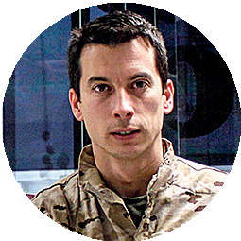

“Military and
Democracy” Forum
General Lopez (Combat Air Command)

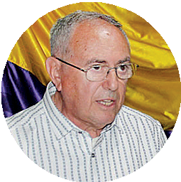Dimas (Head of “Militia and Republic”)
Segura (“The Ukrainian
Trap” book)

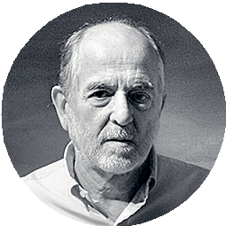Lieutenant Colonel Dominguez

“Military Democrats
for the ANEMOI Republic”

Rebelión

“Ecologists in Action”

“Militia and
Republic”
Civil Association

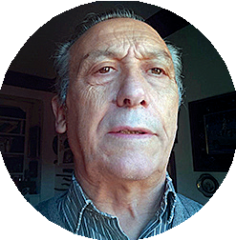Rebelión

Manuel Ruiz Robles

General Ballesta (Chief of Staff of the Rapid
Action Forces)

Association for the Memory of the Military Democrats

Donlebun (AMMD president)

Colonel Vega Fernandez

Geoestrstegia.es

Sputnik
Spanish Institute
of Geopolitics

OHKA Association
Geopolitica.ru

Russia Today

“Ciudadanos
de Uniforme”
Telegram-channel

Pedro Baños (counterintelligence)

General Pitarch (Land Forces Commander)

Colonel Crespo-Frances

Katehon think tank
Leonid Savin

The Eurasia Movement

Aleksandr Dugin

CitizenGO

Association of Spanish Military (AME)

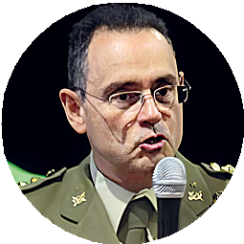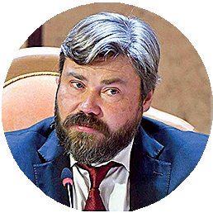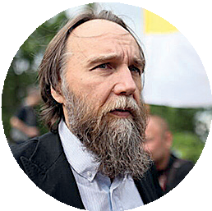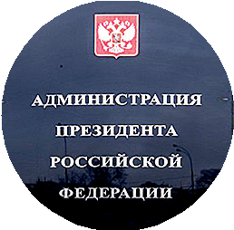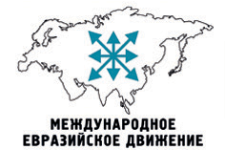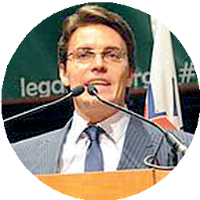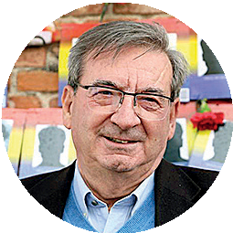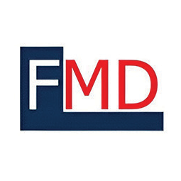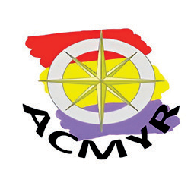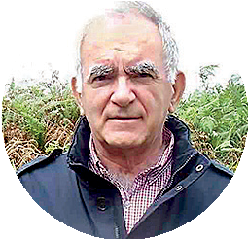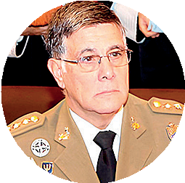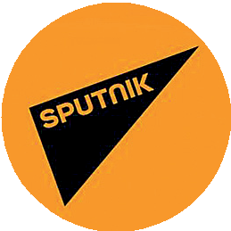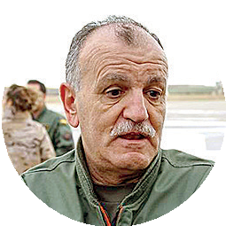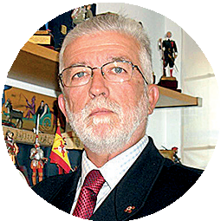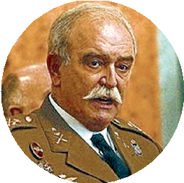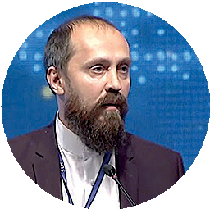

Presidential Administration of Russia
Konstantin Malofeev

Alexei Komov

HazteOir

SOURCES

1 “Kremlin tries to build antiwar coalition in Germany, docu- ments show”. The Washington Post. https://www.washing- tonpost.com/world/2023/04/21/ germany-russia-interfer-
ence-afd-wagenknecht/
2 Paul Sonne, “A Russian bank gave Marine Le Pen’s party a loan. Then weird things began hap- pening”. The Washington Post. https://www.washingtonpost. com/world/national-security/a- russian-bank-gave-marine-
le-pens-party-a-loan-then- weird-things-began-happen- ing/2018/12/27/960c7906-d320- 11e8-a275-81c671a50422_
story.html

3 “Press release on Deputy Foreign Minister Alexander Grushko’s meeting with leader of the La France Insoumise party Jean-
Luc Melenchon”. The Ministry of Foreign Affairs of the Russian Federation. https://www.mid.ru/
en/foreign_policy/news/1570822/
4 “В Іспанії відновилися масові протести проти амністії каталонських сепаратистів”. Європейська правда. https:// www.eurointegration.com.ua/ news/2023/12/4/7174819/
5 Manuil Valls “La Guerra Civil y la guerra de Ucrania: lecciones del pasado para el presente”. Levista de Prensa. https://www.
almendron.com/tribuna/la-guer- ra-civil-y-la-guerra-de-ucrania- lecciones-del-pasado-para-el- presente/

6 “Medio centenar de militares franquistas retirados piden al Ejército que destituya al presidente del Gobierno”.
El País. https://elpais.com/ espana/2023-11-17/medio-cen- tenar-de-militares-franquis- tas-retirados-piden-al-ejerci- to-que-destituya-al-presiden- te-del-gobierno.html

7 “Medio centenar de militares franquistas retirados piden al Ejército que destituya al presidente del Gobierno”.
El País. https://elpais.com/ espana/2023-11-17/medio-cen- tenar-de-militares-franquis- tas-retirados-piden-al-ejerci- to-que-destituya-al-presiden- te-del-gobierno.html
8 “De derechas o izquierdas? Así califican los españoles a PP, PSOE, Podemos, Ciudadanos y VOX”. Epdata.es. https:// www.epdata.es/datos/dere-
chas-izquierdas-asi-califican-es- panoles-pp-psoe-podemos-ciu- dadanos-vox/253

9 Jack Guy, “El partido ultraderechis- ta español Vox arremete contra
los derechos de la mujer y puede ser decisivo en las elecciones del
domingo”. CNN España. https:// cnnespanol.cnn.com/2023/07/21/ partido-ultraderechista-es- panol-vox-derechos-mujer-elec- ciones-generales-trax/

10 “Pablo Iglesias prepara su candidatura a las europeas: “Me han pedido que dé el paso””.
ElDiario. https://www.eldiario.es/ politica/pablo-iglesias-juan-car- los-monedero-candidato-euro- peas-podemos_1_5085192.html

11 Andrés P. Mohorte. “El Partido Comunista de España: de jugar un papel clave en la Transición a confluir con Podemos”.
Xataka. https://www.xataka. com/magnet/el-partido-co- munista-de-espana-de-ju-
gar-un-papel-clave-en-la-transi-
cion-a-confluir-con-podemos
12 Ismael López Muñoz, “El Partido Comunista soviético, dispuesto a financiar parte de la cam- paña del PCE”. El Pais. https:// elpais.com/diario/1979/02/14/es- pana/287794818_850215.html
13 Офіційний сайт Комунистическая партия Российской федерации. https://kprf.ru/rusk/134846.html
14 Atlas España, “Podemos celebra con euforia sus 69 diputados”. ABC. España. https://www. abc.es/espana/abci-podem-
os-celebra-euforia-diputa- dos-4669698984001-
20151221085000_video.html#

15 Paula Chouza, “Sumar sigue con cinco ministerios en el Gobierno: vicepresidencia de Trabajo, Cultura, Sanidad,
Derechos Sociales y Juventud e Infancia”. El Pais. https://el- pais.com/espana/2023-11-20/
sumar-mantiene-los-cinco-min- isterios-en-el-gobierno-vicepres- idencia-de-trabajo-cultura-sa- nidad-derechos-sociales-y-ju- ventud-e-infancia.html
16 EU Parliament official web- site. https://www.europarl. europa.eu/meps/en/search/ad-
vanced?countryCode=ES&euPo- liticalGroupBodyRefNum=427
17 David Alandete, “La red de prop- aganda rusa se apoya en Pode- mos en España”. ABC España. https://www.abc.es/espana/ab- ci-propaganda-rusa-apoya-po- demos-espana-201906022119_ noticia.html
18 Пабло Іглесіас Турріон. Біографія. Busca. Biografias. https://www.buscabiografias. com/biografia/verDetalle/9974/ Pablo%20Iglesias%20Turrion
19 Daniel Iriarte, “RT en Español: How Russian Disinformation Targets 500 Million Spanish Speakers”. Center for Dem- ocratic Integrity. https:// democratic-integrity.eu/
rt-en-espanol-how-russian-dis- information-targets-500-mil- lion-spanish-speakers/
20 José María Triper, “Margallo, sobre Podemos: también reci- ben dinero de Rusia y de Irán”. elEconomista.es. https://www. eleconomista.es/politica/noti-
cias/6520751/03/15/2/Margallo-Po- demos-recibe-tambien-dine-
ro-de-Rusia-y-de-Iran.html

21 Andrea Comas, “Podem- os protesta por el uso en el
Congreso de informes que lo relacionan con Moscú”. Sputnik. https://sputniknews.lat/20171123/ espana-rusia-partido-financia- cion-1074214224.html

22 “IU, Bildu y Podemos se oponen a ampliar las sanciones a Rusia en el Parlamento Europeo”.
Onda Cero. https://www. ondacero.es/noticias/espana/ bildu-podemos-oponen-am- pliar-sanciones-rusia-parla- mento-europeo_20220302621f- 2c2a447ec100015e0e0e.html
23 Gonzalo Araluce, “Podemos culpa a la OTAN de la guerra de Ucrania en vísperas de la cumbre de Madrid”. Vozpopuli. https://www.vozpopuli.com/ espana/podemos-otan-ucra- nia-rusia.html
24 “IU, Bildu y Podemos se oponen a ampliar las sanciones a Rusia en el Parlamento Europeo” Onda Cero. https://www. ondacero.es/noticias/espana/ bildu-podemos-oponen-am- pliar-sanciones-rusia-parla- mento-europeo_20220302621f- 2c2a447ec100015e0e0e.html
25 Carlos Cuesta, “Podemos defiende ya la rendición de Ucrania y ofrece su experien- cia diplomática para alcanzar un acuerdo”. LibertadDigital. https://www.libertaddigital. com/espana/2022-09-12/po- demos-defiende-ya-la-rendi- cion-de-ucrania-y-ofrece-su-ex- periencia-diplomatica-para-al- canzar-un-acuerdo-6930201/

26 “Militares españoles piden a la UE que detenga el en- vío de armas a Ucrania y se
center en un acuerdo de paz”. Público. https://www.publico. es/internacional/militares-es- panoles-piden-ue-detenga-en- vio-armas-ucrania-y-center-ac- uerdo-paz.html
27 “Militares españoles critican la beligerancia de la UE y piden detener el envío de armas a Kiev”. RT. https://actualidad. rt.com/actualidad/469778-mili- tares-espanoles-critican-ue-en- vio-armas-ucrania

28 “El consejo de Ministros nombra a los nuevos jefes del estado May- or de la defensa, Tierra, Armada

y aire”. Ministerio de Defenca. https://www.defensa.gob.es/ gabinete/notasPrensa/2008/07/ notaPrensa_11712.html
29 “El ex JEMAD de Podemos vuelve a ‘incendiar’ los foros militares”. El Confidencial Digital. https://www.elconfi- dencialdigital.com/articulo/ el_chivato/ex-jemad-podem- os-vuelve-incendiar-foros-mili-
tares/20231010171627650280.html
30 “El consejo de ministros nombra a los nuevos jefes del estado mayor de la defensa, tierra, arma- da y aire”. Ministerio de Defensa. https://www.defensa.gob.es/ gabinete/notasPrensa/2008/07/ notaPrensa_11712.html

31 “El Gobierno nombra a José Julio Rodríguez nuevo Jefe del JEMAD”. El Confidencial.
https://www.elconfidencial.com/ espana/2008-07-18/el-gobierno- nombra-a-jose-julio-rodriguez- nuevo-jefe-del-jemad_202022/
32 “El exJEMAD de Podemos, contrario al envío de ‘Leopard’: “Alargar la guerra y aumentar los riesgos de una escalada””. Europa Press. https://www. europapress.es/nacional/noti- cia-exjemad-podemos-contrar- io-envio-leopard-alargar-gu- erra-aumentar-riesgos-escala- da-20230127144520.html
33 José Ignacio Domínguez. Twitter. https://twitter.com/ JIDominguezFMD/sta- tus/1667808980272312324?ref_
src=twsrc%5Etfw%7Ctwcamp% 5Etweetembed%7Ctwter- m%5E166780898027 2312324%7Ctwgr%5E-
3b0ebb15b4b2ed02192458d- 0b8e16f3b1d720579%7Ctwcon% 5Es1_&ref_url=https%3A% 2F%2Ftheobjective. com%2Fespana%
2F2023-06-11%2Fjemad-podem- os-armas-ucranias%2F
34 “José Julio Rodríguez: El problema catalán se soluciona política- mente”. Dario de Leon. https:// www.diariodeleon.es/articulo/ espana/jose-julio-rodriguez-prob- lema-catalan-soluciona-politica- mente/201511042116391551776.html
35 “Бунт в Каталонии: испанская разведка вышла на русский след”. Crime. https://crime-ua. com/node/26257

36 Aurelio Ruiz Enebral, “Podem- os exhibe su vinculación con la asociación ‘Militares con
Futuro’, señalada por intento de subversión”. ECD. https://www.el- confidencialdigital.com/articulo/ defensa/podemos-exhibe-vinc- ulacion-asociacion-militares-fu- turo-senalada-intento-subver- sion/20210906192603273155.html
37 “En el conflicto de Ucrania, Es- paña nada tiene que ganar y sí mucho que perder”. Asociación por la Memoria Militar de- mocrática. https://www.militare- santifascistas.org/2022/01/29/ en-el-conflicto-de-ucrania-es- pana-nada-tiene-que-ganar-y- si-mucho-que-perder/
38 Pilar Casanova, “España, el nuevo portaviones de la OTAN”. Sputnik. https:// sputniknews.lat/20151019/ espana-OTAN-manio- bras-1052632832.html

39 Pilar Casanova, “España, el nuevo portaviones de la OTAN”. Sputnik.
40 Manuel Pardo de Donlebún Montesino, “¿De verdad este gobierno lucha contra el fascis- mo? Manuel Pardo”. Frenta An- tiimperialista Internacionalista. https://frenteantiimperialista. org/de-verdad-este-gobierno- lucha-contra-el-fascismo-ma- nuel-pardo/

41 Manuel Pardo de Donlebún Montesino, “¿De verdad este gobierno lucha contra el fascis- mo? Manuel Pardo”. Frente An- tiimperialista Internacionalista.
42 Víctor Ternovsky, “Es una guerra
de la OTAN contra Rusia”. Sputnik. https://sputniknews. lat/20220624/es-una-guer- ra-de-la-otan-contra-ru-
sia-1127286211.html
43 Víctor Ternovsky, “Es una guerra
de la OTAN contra Rusia”.
Sputnik.
44 “Se funda la organización “Veteranos por la paz Es- paña”. Frente Antiimperialis- ta Internacionalista. https:// frenteantiimperialista.org/
se-funda-la-organizacion-vet- eranos-por-la-paz-espana/
45 “Statement on Ukraine”. Courage to resist. https:// couragetoresist.org/statement- on-ukraine/
46 Manuel Ruiz Robles, “Los militares republicanos del siglo XXI”. Rebelión. https://rebelion. org/los-militares-republica- nos-del-siglo-xxi/
47 Miguel López. Ministerio de De- fensa de España. https://emad. defensa.gob.es/Galerias/emad/ files/CV-TG_SIMON_LOPEZ.pdf
48 “Un militar retirado del Ejército del Aire, candidato de Podemos a la Alcaldía de Azuqueca de Henares”. elDiario. https://www. eldiario.es/castilla-la-mancha/ politica/militar-retirado-ejerci- to-aire-candidato-alcaldia-az- uqueca-henares-guadaja- ra_1_10022312.html
49 Miguel LópezInfoLibre. https:// www.infolibre.es/autores/ miguel-lopez/
50 “Las infames “puertas girato- rias” de nuestros “patriotas” mandos superiores militares”. El Español Digital. https://www. xn--elespaoldigital-3qb.com/ las-infames-puertas-giratori- as-de-nuestros-patriotas-man- dos-superiores-militares/

51 “Militares españoles piden a la UE que detenga el en- vío de armas a Ucrania y se
center en un acuerdo de paz”. Público. https://www.publico. es/internacional/militares-es- panoles-piden-ue-detenga-en-
vio-armas-ucrania-y-center-ac- uerdo-paz.html
52 “Un teniente coronel contin- uará en el Ejército español tras ser condenado por acoso sexual y laboral a una militar, a la que envió un vídeo mastur- bándose”. LuiSegura. https:// www.luisgonzalosegura.es/
un-teniente-coronel-continuara- en-el-ejercito-espanol-tras-ser- condenado-por-acoso-sexual-y- laboral-a-una-militar-a-la-que- envio-un-video-masturbandose/
53 Luis Gonzalo Segura, “La falacia de Ucrania: El relato occidental para defender una democra- cia que no existe”. RT. https:// actualidad.rt.com/opinion/lu- is-gonzalo-segura/471338-fala- cia-ucrania-occidental-de- fender-democracia-inexistente

54 Luis Gonzalo Segura, “La falacia de Ucrania: El relato occidental para defender una democracia que no existe”. RT.
55 Luis Gonzalo Segura, “El nuevo ridículo del Ejército español en el envío de armas a Ucrania”. RT. https://actualidad.rt.com/ opinion/luis-gonzalo-segu- ra/439459-ridiculo-ejercito-es- panol-envio-armas-ucrania
56 Luis Gonzalo Segura, “La trampa ucraniana”. Frente Antiimperialista Internacionalista. https://frentean- tiimperialista.org/la-trampa-ucra- niana-luis-gonzalo-segura/
57 “Militares españoles piden a la UE que detenga el envío de
armas a Ucrania y se center en
un acuerdo de paz”. Público.
58 José Ignacio Domínguez. InfoLi- bre. https://www.infolibre.es/au- tores/jose-ignacio-dominguez/
59 Gonzalo Wancha, “Nos tratan como a cobayas: claman contra el secretismo del accidente nuclear de Palomares”. Sputnik. https://sputniknews.lat/20220117/ nos-tratan-como-a-cobayas-cla-
man-contra-el-secretismo-del-ac- cidente-nuclear-de-palo-
mares-1120400803.html
60 José Ignacio Domínguez, “José Ignacio Domínguez nuevo coordi- nador provincial de Ecologistas en Acción por unanimidad”. Almeria Hoy. https://www.almeriahoy. com/2020/09/ecologistas-en-ac- cion-de-almeria-elige.html
61 “Paremos todas la guerras, empezando por la de Ucrania”. Ecologista. https://www.ecol- ogistasenaccion.org/285653/ paremos-todas-la-guerras-em- pezando-por-la-de-ucrania/

62 “Paremos todas la guerras, empezando por la de Ucrania”. Ecologista.
63 “Oposición ciudadana al gas- oducto MidCat por no tener en cuenta la crisis energética ni la emergencia climática”. Ecologista. https://www.ecol- ogistasenaccion.org/208543/ oposicion-ciudadana-al-gas- oducto-midcat-por-no-ten-
er-en-cuenta-la-crisis-energeti- ca-ni-la-emergencia-climatica/

64 “Російський гібридний вплив на країни Заходу”. Центр оборонних реформ. https:// ghall.com.ua/wp-content/uplo ads/2017/10/%D0%97%D0%B1
%D1%96%D1%80%D0%BA%D0
%B0-%D1%84%D1%96%D0%B- D%D0%B0%D0%BB-%D0% B4%D0%BB%D1%8F-%D0%B- F%D1%83%D0%B1%D0%BB%D1
%96%D0%BA%D0%B0%D1%86
%D1%96%D1%97.pdf
65 Татьяна Шевчук, “Газовые причины каталанского кризиса”. Guildhall. https:// ghall.com.ua/2017/10/11/ga- zovye-prichiny-katalonsko- go-krizisa/
66 Manuel Ruiz Robles, “NO a la guerra!”. FMD. https://www. miliciaydemocracia.org/author/ manuel-ruiz-robles/
67 Quiénes Somos. FMD. https:// www.miliciaydemocracia.org/ quienes-somos/
68 “Autor: Manuel Ruiz Robles”. Foro Milicia y Democracia. https:// www.miliciaydemocracia.org/ author/manuel-ruiz-robles/

69 Manuel Ruiz Robles, “NO a la
guerra!”. FMD.
70 Qui Sommes Nous? Acer Aver. http://acer-aver.com/qui- sommes-nous
71 Floren Dimas. elDiario.es. https:// www.eldiario.es/autores/flor- en_dimas/
72 Floren Dimas. FMD. https:// www.miliciaydemocracia.org/ author/floren-dimas/
73 “Los militares demócratas frente al franquismo”. La Voz de la República. https://www. lavozdelarepublica.es/2023/02/ los-militares-democratas-
frente-al.html
74 “La oscura realidad de los archi- vos militares en España: falta personal para gestionar tanta memoria”. Publico. https://www. publico.es/politica/oscura-re- alidad-archivos-militares-es- pana-falta-personal-gestion- ar-memoria.html
75 Floren Dimas, “Vuelve la pregunta: ¿cañones o man- tequilla?”. Rebelión. https:// rebelion.org/vuelve-la-pregun- ta-canones-o-mantequilla/
76 Floren Dimas, “Vuelve la pregunta: ¿cañones o man- tequilla?”. Rebelión. https:// rebelion.org/vuelve-la-pregun- ta-canones-o-mantequilla/
77 Leonid Savin. Rebelión. https:// rebelion.org/autor/leonid-savin/
78 Leonid Savin. Ketehon. https:// katehon.com/ru/person/le- onid-savin

79 “The weaponization of religion: How the Kremlin is using Christian fundamentalism to advance Moscow’s agenda”.
День. https://day.kyiv.ua/en/ article/day-after-day/weaponi- zation-religion-how-kremlin-us- ing-christian-fundamental-
ism-advance
80 Maxim Medovarov, “El pueblo contra el parlamentarismo”. Rebelión. https://rebelion.org/ el-pueblo-contra-el-parlamen- tarismo/
81 “Сети российского вмеша- тельсва в Испании”. InfoPressa. https://www.inopressa.ru/article/ 02jan2018/elpais/elpais_rus.html#
82 Karina Makarenko, “La geopolíti- ca de los Estados pequeños del Caribe”. Rebelión. https://rebeli- on.org/la-geopolitica-de-los-es- tados-pequenos-del-caribe/
83 “Экс-зек Волга идет на выборы в “Л/ДНР”, чтобы “объединить страну”” Dsnews.ua. https://www.dsnews.ua/politics/ eks-zek-volga-idet-na-vy-
bory-l-dnr-chtoby-obedinit- stranu--06042016134300
84 Maxim Goldarb, “Monumen- tos a los nazis con dinero de Estados Unidos y de Europa?”. Rebelión. https://rebelion.org/ monumentos-a-los-nazis-con-
dinero-de-estados-unidos-y-de- europa/
85 Maxim Goldarb, “Sobre la corrupción militar en Ucrania”. Rebelión. https://rebelion.org/ sobre-la-corrupcion-mili-
tar-en-ucrania/
86 Maxim Goldarb, “Cómo se está destruyendo la libertad de expresión en Ucrania”. Rebelión. https://rebelion.org/como-se-es- ta-destruyendo-la-libertad-de- expresion-en-ucrania/
87 Pablo Iglesias Turrión. Статті. Rebelión. https://rebelion.org/ autor/pablo-iglesias-turrion/

88 “Militares españoles piden a la UE que detenga el envío de ar- mas a Ucrania y se center en un acuerdo de paz”. Público.
⁸⁹ Aurelio Ruiz Enebral, “Podemos exhibe su vinculación con la asociación ‘Militares con Futuro’, señalada por intento de sub- versión”. ECD. https://www.elcon- fidencialdigital.com/articulo/ defensa/podemos-exhibe-vinc- ulacion-asociacion-militares-fu- turo-senalada-intento-subver- sion/20210906192603273155.html
90 Aurelio Ruiz Enebral, “Podemos exhibe su vinculación con la asociación ‘Militares con Futuro’, señalada por intento de sub- versión”. ECD. https://www.el- confidencialdigital.com/articulo/ defensa/podemos-exhibe-vinc- ulacion-asociacion-militares-fu- turo-senalada-intento-subver- sion/20210906192603273155.html
91 “Podemos hizo campaña y buscó socios para “Militares Con Futuro””. ECD. https:// www.elconfidencialdigital. com/articulo/el_chau-chau/ podemos-hizo-campa-
na-asociarse-militares-fu- turo/20211221175352324247.html
92 Aurelio Ruiz Enebral, “Podemos exhibe su vinculación con la asociación ‘Militares con Futuro’, señalada por intento de sub- versión”. ECD. https://www.el-
confidencialdigital.com/articulo/ defensa/podemos-exhibe-vinc- ulacion-asociacion-militares-fu- turo-senalada-intento-subver- sion/20210906192603273155.html
93 Aurelio Ruiz Enebral, “Podemos exhibe su vinculación con la asociación ‘Militares con Futuro’, señalada por intento de sub- versión”. ECD. https://www.el- confidencialdigital.com/articulo/ defensa/podemos-exhibe-vinc- ulacion-asociacion-militares-fu- turo-senalada-intento-subver- sion/20210906192603273155.html
94 Pascual Serrano, “Soldados neonazis en la Otan”. Sput- nik. https://sputniknews. lat/20210330/soldados-neona- zis-en-la-otan-1110596130.html
95 Aurelio Ruiz Enebral, “Podemos exhibe su vinculación con la asociación ‘Militares con Futuro’, señalada por intento de sub- versión”. ECD. https://www.el- confidencialdigital.com/articulo/ defensa/podemos-exhibe-vinc- ulacion-asociacion-militares-fu- turo-senalada-intento-subver- sion/20210906192603273155.html
96 “Asociación “Tercios Viejos españoles””. Tercios Viejos españoles. https://asociacionter- ciosviejos.com/
97 Aurelio Ruiz Enebral, “Podem- os exhibe su vinculación con la asociación ‘Militares con Futuro’, señalada por intento de subversión”. ECD. https:// www.elconfidencialdigi- tal.com/articulo/defensa/ podemos-exhibe-vincula- cion-asociacion-militares-fu-
turo-senalada-intento-subver- sion/20210906192603273155.
html
98 Aurelio Ruiz Enebral, “Pode- mos exhibe su vinculación con la asociación ‘Militares con Futuro’, señalada por intento de subversión”. ECD. https://www.elconfidencialdig- ital.com/articulo/defensa/ podemos-exhibe-vincula-
cion-asociacion-militares-fu- turo-senalada-intento-subver- sion/2021090619260327
3155.html
99 Marisa Cruz, “Pedro Pitarch: “Los militares vemos que ni PP ni PSOE han combatido al independentismo””. EM. https://www.elmundo.es/es-
pana/2019/03/20/5c9157d421e- fa0c90d8b45e4.html

100 Marisa Cruz, “Pedro Pitarch: “Los militares vemos que ni PP ni PSOE han combatido al independentismo””. EM.
101 Fulgencio Coll Bucher. Elec- ciones. https://elecciones.cope. es/detalle-candidato/Fulgen- cio-Coll-Bucher/158
102 “Un general retirado encabeza lista de Vox por Cádiz al Con- greso”. Publico https://www. publico.es/politica/agustin-ro- sety-fernandez-castro-gen- eral-retirado-encabeza-lis-
ta-vox-cadiz-congreso.html

103 Luis Carlos Llera. “Antonio Budiño Carballo: “No veo series, tengo canales de pago para ver fútbol””. La voz de Galicia .
https://www.lavozdegalicia.es/no- ticia/elecciones-2020/2019/11/06/ antonio-budino-carballo-veo-se- ries-canales-pago-ver-futbol/ 00031573076054704943294.html

104 “General Asarta, ex jefe de FINUL: ‘Ser jefe de la misión y comandante de la Fuerza te llena completamente’”.
Ejercito de tierra. https://ejerci- to.defensa.gob.es/va/actuali- dad/2012/01/1391.html
105 “Vox tira de generales retirados para sus listas, algunos abier- tamente franquistas”. Publico. https://www.publico.es/espana/ elecciones-vox-tira-gener-
ales-retirados-listas-abierta- mente-franquistas.html
106 “Vox escenifica que su líder en la provincia de Alicante es el teniente general Ma- nuel Mestre”. El Espanol. https://www.elespanol. com/alicante/20230123/
vox-escenifica-provincia-ali- cante-teniente-manuel-mes- tre/735176665_0.html
107 “Vox se estrenará en el Par- lamento navarro presidien- do la mesa de edad con un militar retirado”. Naiz. https:// www.naiz.eus/es/info/noti- cia/20230530/el-parlamentar- io-de-vox-emilio-jimenez-pre-
sidira-la-constitucion-del-par- lamento-navarro
108 Irina Marzo, “Vox presenta su candidatura al 28M para “de- volver la ilusión a Córdoba” y darle “el impulso que merece””. Córdoba. https://www. diariocordoba.com/cordo-
ba-ciudad/2023/04/23/vox-pre- senta-candidatura-28m-de- volver-86381923.html

109 “Quién es quién en la lista de Vox a las elecciones munic- ipales en Córdoba capital”.
Diare Córdoba. https://www. diariocordoba.com/elecciones/ municipales/2023/04/24/
lista-vox-elecciones-munici- pales-cordoba-86414719.html
110 Rafa Martínez, “¿Son las Fuerzas Armadas de extrema derecha?”. El Periódico. https://www.elperi- odico.com/es/opinion/20190331/ articulo-opinion-son-fuer-
zas-armadas-extrema-dere- cha-rafa-martinez-7383657
111 “Abascal relaciona a Putin con la izquierda y muchos le recuerdan este tuit de 2015”. Huffington Post. https://www.huffingtonpost. es/entry/abascal-relaciona-a-pu- tin-con-la-izquierda-y-muchos-le- recuerdan-este-tuit-de-2015_ es_621a7a89e4b03d0c8039 aedc.html
112 Cristina Pita, “Una red de ultraderecha une a Vox con los oligarcas rusos de Putin a través de HazteOir y CitizenGo”. El Espanol. https://www.elespanol. com/reportajes/20220319/
ultraderecha-vox-oligarcas-pu- tin-traves-hazteoir-citizen- go/658184665_0.html
113 Cristina Pita, “Una red de ultraderecha une a Vox con los oligarcas rusos de Putin a
través de HazteOir y CitizenGo”.
El Espanol.
114 “Религия – еще одно оружие России”. Аргумент. https://ar- gumentua.com/stati/religiya-es- hche-odno-oruzhie-rossii
115 “Немецкого депутата раскрыли на связях с финансистом протестов из Кремля”. Guildhall. https://ghall. com.ua/2022/12/04/nemetsko- go-deputata-raskryli-na-svy- azyah-s-finansistom-protes- tov-iz-kremlya/

116 Cristina Pita, “Una red de ultra- derecha une a Vox con los oli- garcas rusos de Putin a través de HazteOir y CitizenGo”. El Espanol.
117 Carlos Enrique Bayo, “Grandes fortunas y altos ejecutivos españoles financiaron el nacimiento de Vox a partir
del grupo ultracatólico Hazte Oír”. Público. https://www. publico.es/politica/exclusi-
va-wikileaks-grandes-for- tunas-altos-ejecutivos-es- panoles-financiaron-nacimien- to-vox-partir-grupo-ultracatol- ico-hazte-oir.html
118 Jesús Bastante, “HazteOir ‘rompe’ con Vox por no exigir la derogación de las leyes LGBTI en Murcia y Madrid”. Religión Digital. https://www.religiondigi- tal.org/espana/HazteOir-Vox-LG- BTI-Murcia-Madrid-losantos-ci- udadanos-pp-gays-ultradere- cha-yunque_0_2145385463.html
119 “Spanish populist party leader attacked with rocks during Madrid speech”. Katehon. https://katehon.com/en/news/ spanish-populist-party-lead- er-attacked-rocks-during-ma- drid-speech
120 Adam Ramsay, Claire Provost, “Revealed: the Trump-linked ‘Super PAC’ working behind the scenes to drive Europe’s voters to the far Right”. Open Democracy. https://www. opendemocracy.net/en/5050/ revealed-the-trump-linked-su- per-pac-working-behind-the- scenes-to-drive-europes-vot- ers-to-the-far-right/
121 Adam Ramsay, Claire Provost, “Revealed: the Trump-linked ‘Super PAC’ working behind the scenes to drive Europe’s voters to the far Right”. Open Democracy. https://www. opendemocracy.net/en/5050/ revealed-the-trump-linked-su- per-pac-working-behind-the- scenes-to-drive-europes-voters- to-the-far-right/
122 “Розкриті імена росіян, причетних до фінансування італійської партії “Ліга Півночі””. РБК-Україна. https://www.rbc.ua/ukr/news/ raskryty-imena-rossiyan-pri-
chastnyh-finansirovani- yu-1567524756.html

123 Marine Matsumura, “Madrid:
the Far-Right Imbroglio”. Latest. https://mjps.ssmu. ca/2022/02/18/madrid-the-far- right-imbroglio/

124 Ramón González Férriz, “¿Se ha vuelto Vox europeísta a su
pesar?”. El Confidencial. https:// blogs.elconfidencial.com/ espana/tribuna/2023-11-26/
vox-europeista-a-su-pe- sar_3781793/
125 Bernardo de Miguel, “Una coalición con Vox daría a los gobiernos euroescépticos el peso necesario para paralizar la UE”. Agenta Publica. https:// agendapublica.elpais.com/
noticia/18742/coalicion-con-vox- daria-gobiernos-euroesc-pticos- peso-necesario-paralizar-ue
126 Xabier Deop, “El programa de Vox es incompatible con la UE”. El Diario.es. https://www.
eldiario.es/opinion/tribuna-abi- erta/programa-vox-incompati- ble-ue_129_10361947.html
127 Cristina Vázquez, “Los es- pañoles perciben a los políticos como el grupo de población más corrupto, según una encuesta”. El Pais. https:// elpais.com/espana/comuni- dad-valenciana/2022-12-12/
los-espanoles-perciben-a-los- politicos-como-el-grupo-de- poblacion-mas-corrupto-se- gun-una-encuesta.html#
128 “La telenovela sobre el lider- azgo de Ucrania continúa en ebullición”. Geostradegia.es. https://geoestrategia.es/

129 Juan Antonio Aguilar.
Geoполитика.ru. https://www. geopolitika.ru/es/person/
juan-antonio-aguilar
130 “Alexander Dugin and the “Eur- asian” System: Philosophy and Strategy”. Strategiecs. https:// strategiecs.com/en/analyses/ alexander-dugin-and-the-eur- asian-system-philoso-
phy-and-strategy
131 Javier Galán Caballerojosé, Manuel Abad Liñán ,“La propaganda rusa crea webs para la ultraderecha españo- la”. El Pais. https://elpais.com/ politica/2017/12/29/actuali- dad/1514571739_505859.html
132 Quienes Somos. Geoestrate- gia. https://geoestrategia.es/ quienes-somos

133 Данило Хмільник, “Незаконні візити інозмених громадян на території окупованого Криму в лютому-травні 2018. Підсумки моніторингу”.
Майдан закордонних справ. https://www.mfaua.org/uk/ projects/nezakonni-vizyty-in- ozemnykh-hromadian-na-tery- toriiu-okupovanoho-krymu-v-liu- tomu-travni-2018-pidsumky-mo- nitorynhu?fbclid=IwAR39Am- Ftij6V9TjtZCRjrYl1RQLRXKv9k_ V258l2M82FlT2h3FaSqZfGN0A

134 “Іноземні “спостерігачі” за незаконними виборами на Херсонщині. Хто вони?”.
ІРС-Південь. https://ipc.org.ua/ uk/2023/09/inozemni-sposter- igachi-za-nezakonnymy-vy- boramy-na-hersonshhy-
ni-hto-vony/
135 Victoria, “Entrevista con Alex- ander Dugin: “Nueva Rusia es mucho más que Rusia, es el mundo multipolar, es la resistencia contra el Nuevo Orden Mundial””. Geoestrate- gia. https://geoestrategia.
es/11799-entrevista-con-alexan- der-dugin-nueva-rusia-es-mu- cho-mas-que-rusia-es-el-mun- do-multipolar-es-la-resistencia- contra-el-nuevo-orden-mundial
136 Armando Robles, “Presenta- dos en Madrid dos libros de Aleksander Dugin: “Funda- mentos de Geopolítica” y “Platonismo político”, ya dis- ponibles para leer en español”. Alerta Digital. https://www. alertadigital.com/2023/03/13/ presentados-en-ma-
drid-dos-libros-de-aleksand- er-dugin-fundamentos-de-ge- opolitica-y-platonismo-po- litico-ya-disponibles-pa-
ra-leer-en-espanol/

137 “La Conferencia Mundial sobre la Multipolaridad reunió a representantes de 63 países. La bandera está alzada…
Algunos discursos”. Geoestrate- gia. https://geoestrategia.es/ noticia/40596/ultimas-noticias/ la-conferencia-mundial-so- bre-la-multipolaridad-reu-
nio-a-representantes-de-63-pais- es.-la-bandera-esta-alzada-al- gunos-discursos.html

138 “La Conferencia Mundial sobre la Multipolaridad reunió a representantes de 63 países. La bandera está alzada… Algunos discursos”. Geoestrategia.
139 “Crisis marroquí en clave algo más geopolítica”. Geoestrate- gia. https://geoestrategia.es/ noticia/34339/geoestrategia/ crisis-marroqui-en-clave-al- go-mas-geopolitica.html
140 “El teniente general Pedro Pitarch nombrado jefe de la fuer- za terrestre”. Ministerio de Defen- sa. https://www.defensa.gob.es/ gabinete/notasPrensa/2006/01/ notaPrensa_10858.html
141 “EUROCORPS: Symbol of European Will in the European Security and Defense Policy”. EU parliament website. https:// www.europarl.europa.eu/ cmsdata/175566/20080507AT- T28367EN.pdf
142 Pedro Pitarch, “Al Fido Del 20d”. Geoполитика.ru. https://www. geopolitika.ru/es/article/al-fido- del-20d

143 “La OTAN afronta obstáculos logísticos en su desplieg-
ue en Europa Oriental”. RT. https://actualidad.rt.com/ video/229404-otan-desplieg- ue-europa-oriental
144 “Estados Unidos e Israel están haciendo estallar Oriente Próximo para ocultar su desastrosa derrota en Gaza. Análisis”. Geoestrategia. https:// geoestrategia.es/

145 Enrique Andrés Pretel, Ángel Villarino, “Los pronósticos
de dos generales españoles sobre lo que viene en Ucra- nia”. El Confidencial. https:// www.elconfidencial.com/ mundo/2022-03-03/pronosti- cos-generales-espanoles-fu- turo-ucrania_3385366/
146 Pedro Pitarch, “Putin, ese tipo con suerte”. El Blog de Pedro Pitarch. https://elblogdepitarch. blogspot.com/
147 “Decenas de militares exigen mejoras en salarios para dig- nificar la profesión”. Ei Mundo. https://www.elmundo.es/es- pana/2022/06/25/62b6fdacfc- 6c83e4648b45eb.html
148 Pedro Pitarch, “Enrarecimiento de la atmósfera bélica”. ABC. Internacional. https://www. abc.es/internacional/enrare- cimiento-atmosfera-beli-
ca-20230201174328-nt.html
149 Pedro Pitarch, “Del discurso atómico”. El Blog de Pedro Pitarch. https://elblogdepitarch. blogspot.com/2022/04/del-dis- curso-atomico.html
150 Víctor García Guerrero, “Entre- vista en TVE | Guerra en Ucrania Pedro Pitarch, teniente general: “Rusia tiene prisa por romper el frente del Donbás””. RTVE. https:// www.rtve.es/noticias/20230224/ entrevista-teniente-gener-
al-pitarch-rusia-frente-don- bas/2427406.shtml
151 “Resultados de búsqueda para Pedro Pitarch”. Asociación De Militares Españoles. https:// ame1.org.es/?s=Pedro+Pitarch
152 Pedro Pitarch, “Crece el rechazo al apoyo militar a Ucrania”. Aso- ciación De Militares Españoles. https://ame1.org.es/crece-el-re- chazo-al-apoyo-militar-a-ucra- nia-pedro-pitarch/
153 “Dos Estados y dos portaavi- ones”. Geoestrategia. https:// geoestrategia.es/noticia/41770/ opinion/dos-estados-y-dos-por- taaviones.html

154 Enrique Vega Fernández.
Біографія. ICEX. https://www. newspanishbooks.com/author/ enrique-vega-fernandez

155 “Carta abierta al general Pitarch”.
AME. https://ame1.org.es/car- ta-abierta-al-general-pitarch/

156 Enrique Vega Fernández.
Gobierno de Espana. https:// www.newspanishbooks.com/ author/enrique-vega-fernandez
157 Enrique Vega Fernández, “Consideraciones sobre los Leopard”. FMD. https://www. miliciaydeнmocracia.org/con- sideraciones-sobre-los-leopard/

158 Enrique Vega Fernández, “Todo lo que no te han contado
sobre el envío de los Leopard a Ucrania”. FMD. https://www.mili- ciaydemocracia.org/todo-lo-que- no-te-han-contado-sobre-el-en- vio-de-los-leopard-a-ucrania/
159 Enrique Vega Fernández, “Sabotajes en los Nord Stream”. InfoLibre. https://www.infolibre. es/opinion/blogs/foro-mili-
cia-democracia/sabota-
jes-nord-stream-rusia-ucra- nia_132_1340861.html
160 “Valentia Forum, con vín- culos franquistas, dará una conferencia en instalaciones militares ante la permisividad de Defensa”. Asociacion por la Memoria Militar Democrat- ica. https://www.militaresan- tifascistas.org/2021/09/24/ valentia-forum-con-vincu-
los-franquistas-dara-una-con- ferencia-en-instalaciones-mil- itares-ante-la-permisivi-
dad-de-defensa/
161 Pilar Casanova, “España, el nuevo portaviones de la OTAN”. Sputnik. https:// sputniknews.lat/20151019/ espana-OTAN-manio- bras-1052632832.html
162 “En el conflicto de Ucrania, España nada tiene que ganar y sí mucho que perder”. Nueva Tribuna. https://www.nueva- tribuna.es/articulo/actualidad/ conflicto-ucrania-espana-na- da-tiene-que-ganar-mu-
cho-que-perder/202201 26101916194851.html
163 Quienes somos. Geoestrate- gia. https://geoestrategia.es/ quienes-somos
164 José Antonio Crespo-Francés. Біографія. Actas. https://www. actashistoria.com/autor. php?go=2&idautor=1280

165 José Antonio Crespo-Francés.. “Insisto en que la guerra
en Ucrania ni nos va ni nos viene. Por José Crespo”. La Paseata. https://lapaseata. net/2022/02/24/la-guerra-en- ucrania-ni-nos-va-no-nos-viene/

166 Carlos de Castillo. “Militares franquistas integran un órgano rector de Defensa”.
Publico. https://www.publico. es/sociedad/militares-fran- quistas-integran-organo-rec- tor-defensa.html
167 José Antonio Crespo-Francés., “Víctimas y Verdugos”. La Paseata. https://ame1.org.es/ victimas-y-verdugos/
168 Presentación del libro. Tele- gram “La Falange”. https://t.me/ LaFalangeOficial/858

169 Quienes somos. Geoestrategia.
170 Salvador Fontenla Ballesta. Асоціація. Asociación Es- pañola de Militares Escritores. https://militaresescritores.es/ quienes-somos-como-aso- ciarse/
171 Manual escolar de cultura de de- fensa para estudiantes de la E.S.O. Dialnet. https://dialnet.unirioja.es/ servlet/libro?codigo=721412

172 Javier Galán Caballerojosé, Manuel Abad Liñán, “Redes de ingerência russa alimentam extrema-direita na Europa”. El Pais. https://brasil.elpais.com/ brasil/2017/12/29/internacion- al/1514571739_505859.html
173 Paolo Mastrolilli, Gianluca Paolucci. “A sanctioned Rus- sian oligarch among Salvini’s contacts”. La Stampa. https:// www.lastampa.it/esteri/la- stampa-in-english/2019/07/12/ news/a-sanctioned-russian- oligarch-among-salvini-s-con- tacts-1.36981458/
174 “Anders rasmussen dice que la otan rearmará a Ucrania con “armas letales””. Geoполитика. ru. https://www.geopolitika. ru/es/news/anders-rasmus- sen-dice-que-la-otan-rear- mara-ucrania-con-armas-le- tales?page=50
175 Miguel Pérez Pichel, “Una postura más neutral en Ucrania sería más beneficiosa para España”. El Debate. https://www. eldebate.com/internacion- al/20220603/no-se-que-le-perdi- do-espana-guerra-ucrania-afir- ma-general-fontenla.html

176 Miguel Pérez Pichel, “Una postura más neutral en Ucrania sería más beneficiosa para España”. El Debate.
177 “Defensa censura el artículo de un General por sus críticas a la misión de España y la OTAN en Afganistán”. Asoci- ación Española de Militares Escritores. https://ame1.org.es/ defensa-censura-el-articulo-
de-un-general-por-sus-criticas- a-la-mision-de-espana-y-la- otan-en-afganistan/
178 Salvador Fontenla Ballesta, “La defensa de Ceuta, Melilla y de las Islas y Peñones del Estrecho”. Periodista Digital. https://www.periodistadigital. com/politica/opinion/20211215/ salvador-fontenla-balles-
ta-defensa-ceuta-melilla-is- las-penones-estrecho-noti- cia-689404547712/
179 María Cristina Henríquez Jiménez, “Búsqueda... Las Capacidades Militares De La Unión Europea por Salvador Fontenla Ballesta”. DocPlay- er.es. https://docplayer. es/73519368-Las-capaci- dades-militares-de-la-un-
ion-europea-por-salva- dor-fontenla-ballesta. html#google_vignette

180 Anabel Díez, Javier Casqueiro, “El candidato a director de
la Seguridad Nacional es un defensor de Rusia”. El Pais. https://elpais.com/polit- ica/2018/06/07/actuali- dad/1528372493_075633.html
181 Instituto de Censores jurados de Cuentas de España. Pedro Baños Bajo. https://www.icjce. es/adjuntos/p-banos.pdf
182 Alberto López Girondo, “Cuan- do Estados Unidos toca el silba- to, todos vamos detrás, como pasó en Afganistán”. Tiempo. https://www.tiempoar.com.ar/ mundo/pedro-banos-cuan-
do-estados-unidos-toca-el-sil- bato-todos-vamos-detras-co- mo-paso-en-afganistan/
183 “Militar español llama a normalizar las relaciones con Rusia”. Sputnik. https:// sputniknews.lat/20151124/
Militar-espanol-llama-a-nor- malizar-relaciones-con-Ru- sia-1054060582.html
184 Pedro Baños. Статті. Vatnik Soup. https://vatniksoup.com/ en/soups/116/

185 Анастасія Одінцова, “Годовщина катастрофы МН17.
Как Россия цинично лжет и создает фейки, пытаясь избежать ответсвенности”.
New Voice. https://nv.ua/world/ geopolitics/kak-rossiya-cin- ichno-sozdaet-feyki-o-katast- rofe-boinga-mh17-2014-go-
da-poslednie-nov- osti-50099744.html
186 “El candidato a director de la Seguridad Nacional es un defensor de Rusia”. El País. https://elpais.com/polit- ica/2018/06/07/actuali-
dad/1528372493_075633.html
187 “Integrity Initiative is the biggest story of 2018 – but not because of anything it did”. RT. https://www.rt.com/ news/447256-integrity-initia-
tive-psyops-establishment-media/
188 Víctor Ternovsky, “Brutal injer- encia en seguridad nacional: España cae víctima de ma- nipulación británica”. Sputnik. https://sputniknews.lat/20181226/ madrid-londres-relaciones- moscu-1084393925.html

189 Pedro Baños. Статті. Vatnik Soup.
190 “La guerra de Ucrania | Pedro Baños: “Las sanciones a Rusia han sido como un búmeran”. YouTube channel “Canal26”. https://www.youtube.com/ watch?v=aKsQlOwDYgg
191 Pedro Baños, “Conspiraciones y ultraderecha: de Pedro Baños a Hazte Oír”. Lamarea. https:// www.lamarea.com/2021/08/10/
conspiraciones-y-ultraderecha- de-pedro-banos-a-hazte-oir/
192 Асоциация OHKA. Geoполитика.ru. https://www. geopolitika.ru/es/person/ohka

193 “Информационно- аналитический портал “ГЕОПОЛИТИКА””. НАЗК.
https://sanctions.nazk.gov.ua/ ru/sanction-company/252/
194 Víctor Lenore. Twitter. https:// twitter.com/lenore1789/sta- tus/1201851971831025664
195 Eduardo Buxens. “Coronel Pe- dro Baños: “Aportar armamen- to a Ucrania no es el camino adecuado””. Diario de Navarra. https://www.diariodenavarra. es/noticias/navarra/2022/04/23/ coronel-pedro-banos-apor-
tar-armamento-ucra-
nia-no-el-camino-adecua- do-524975-300.html
196 Pedro Baños. “Cuando Estados Unidos toca el silbato, todos vamos detrás, como pasó en Afganistán”. Tiempo. https:// www.tiempoar.com.ar/mundo/ pedro-banos-cuando-esta- dos-unidos-toca-el-silbato-to- dos-vamos-detras-como-pa- so-en-afganistan/
197 Cristina Vázquez, “Los es- pañoles perciben a los políticos como el grupo de población más corrupto, según una encuesta”. El Pais. https:// elpais.com/espana/comuni- dad-valenciana/2022-12-12/
los-espanoles-perciben-a-los- politicos-como-el-grupo-de- poblacion-mas-corrupto-se- gun-una-encuesta.html
198 “Un estudio europeo sitúa a los españoles como los más proclives a negociar con Rusia la paz”. ServiMedia. https:// www.servimedia.es/noticias/ estudio-europeo-situa-es- panoles-como-mas-pro-
clives-negociar-rusia-paz-ucra- nia/3696896

